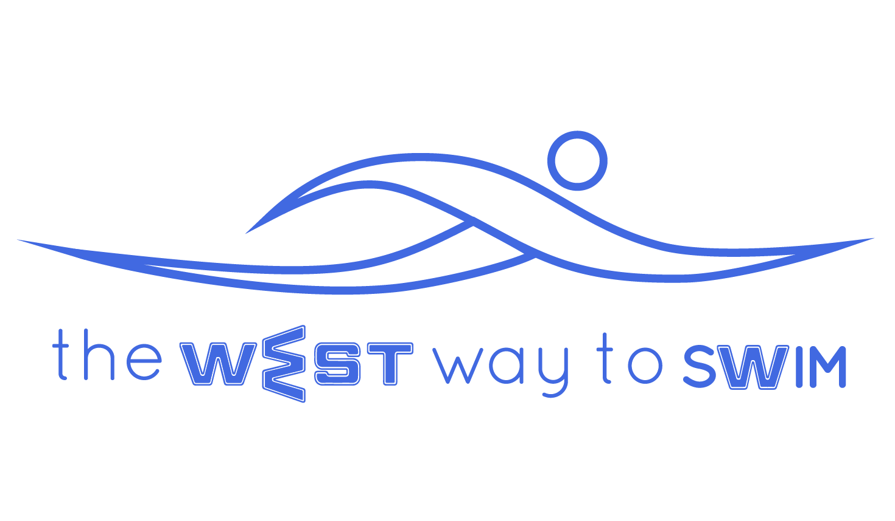
5.0 The goal of session #5: Learn the holy triangle, work with pulse, control the swim pace of 100 meters with fins with 12-14 strokes per length and glide off the wall.
No | The Drill & Goals | Duration in min | WEST Key Principles | From theory to practice
5.1 | 100-400 meters freestyle with fins.  Every second length - two arm backstroke.  Every fourth length - regular backstroke. | 8 | Regular backstroke - breathing + position of arm when entering the water.  3.7.2 - Double arm backstroke | Swim 100-400 m freestyle with fins, maintaining 12-14 strokes per length.  Every second length swim two arm backstroke (3.7.2 - Arms besides the body. Raise palms along sides of the body until thumbs touch armpits. Stretch arms to the side in a T shape and lower straight arms back towards sides).  Every fourth length regular backstroke.  When you swim backstroke inhale when one arm exits the water and exhale when the other one exits.  position of arm when entering the water:  A - 20cm from ear  B - 10cm from ear  C - Almost touching the ear
5.1.1 Pulse video clip- Comprehending the purpose of the pulse and utilizing it to enhance the cardiovascular work, extension of the strokes and from this point onwards- improve the cardiovascular work together with preserving the personal WEST technique.
5.2 | 4-8X50 meters with fins, while maintaining a steady pulse.  5.2.1 Streamline glide off the wall according to personal WEST | 8 | KP9-streamline  Measuring pulse | Swim 4-8 times 50m freestyle with fins, streamline gliding off the wall according to your personal WEST. At the end of each 50m take your pulse, and try to maintain pulse at 65% (around 21-22 beats in 10 seconds). Also do a streamline stretch (1.7.3) twice, 10 sec each.  Streamline glide off the wall according to personal WEST:  A - Glide off the wall with no legwork and stretch to the maximum for 3 sec, then continue swimming.  B - Glide off the wall while kicking your legs and then add arm strokes.  C - Glide off the wall with 2-4 dolphin moves and then continue swimming.
5.3 | Walking for 30 sec + swimming 1.5 min for every KP. | 6 | (5.31)KP2 - Angle between arm and forearm  (5.32(KP4 - Angle of palm when entering the water.  (5.33)KP7 - End of pull. | For each KP walk for 30 sec to see and feel that you do it correctly, and then practice same KP in swimming.  Angle between arm and forearm:  A - Angle when palm enters the water is 90 degrees  B - 120 degrees  C - 160 degrees  Angle of palm when entering the water:  A - 45 degrees  B+C - 0 degrees  End of pull:  A - Finish pull when palm is near the inner thigh  B - Near the middle part of the thigh  C - Outer thigh
5.4 | 6-10X25  The Holy Triangle | 8 | 1.7.3 - Streamline stretch  4.5.1 - Inverted streamline stretch | In this exercise we will try and reach a pulse of 20-22, and understand our swimming pace for 25 meters at this pulse rate. It is important to note how many strokes you do per length.  For example: S=19, P=22, T=38  P=Pulse, T=Time, S=Strokes  ** Future goal is 16 strokes per length.  Between every 25m do a streamline and inverted streamline stretches (1.7.3 + 4.5.1)
5.5 | 3-6X100 with fins, 12-14 strokes per length. Between every 100 meters, 30 seconds fin stretch. | 10 | 2.5.1 - Fin stretch | Swim 3-6 times 100m freestyle with fins, breathing every 3 strokes, maintaining 12 strokes per length.  Between every 100m do a fin stretch (2.5.1) for 30 sec (7-10 sec per each leg)
5.6 | 3-6X100 without fins. Figuring out the swimming pace per 100 meters. Between each 100, 45 seconds of stretching. | 16 |  | Swim 3-6 times 100m freestyle without fins, breathing every 3 strokes. The goal is to swim easily, relatively slowly, but to grasp your exact time for 100m freestyle.  Between every 100m rest for 45 sec exactly and perform stretches of your choice.
5.7 | Various arm stretches | 4
5.8 In case you feel like you do not have enough breath to swim 100 meters continuously without fins, that is fine. You can rest between lengths. It is important to take note at this stage what your time is for 100 meters freestyle (including breaks), does it take you 1:59 or 3:24 to swim 100 meters?
5.9 Weekly tip: It is preferable to swim slowly and extend our glide with every stroke. Long efficient strokes will assist in the future with swimming fast with ease.

